GRADE |  | SUBJECT |  | CAT |  | WEEK |  | W2  L1 |  | TOPIC | Computer Management Part 1
LESSON SUMMARY FOR:
DATE STARTED |  |  |  |  |  |  | DATE COMPLETED
LESSON OBJECTIVES |  |  | At the end of this lesson the learner must be able to:  - Understand and make Shortcuts  - Understand and make Screenshots  - To compress a file or folder  - To Decompressing files and folders
TEACHER ACTIVITIES |  |  |  |  |  |  |  |  | LEARNER ACTIVITIES |  |  |  | TIMING | RESOURCES NEEDED
- Methodology  NOTE TO THE TEACHER: This is a theory as well as a practical lesson on Computer Management  Use the PowerPoint presentation as an aid to this lesson  Open the PowerPoint presentation for this lesson Week 2 Lesson 3.pptx  - Introduction  In this lesson demonstrate  - Shortcuts  - Screenshots  - Compressing  - Decompressing files  - Main Body (Lesson presentation)  Shortcuts  A Shortcut is a icon that works like a link to a specific program, file or folder  - Creating Shortcuts  Right-click on desktop and choose New from menu, Select Shortcut, Browse to the folder you want to be a shortcut and enter the name  - Lets say you want Microsoft Excel to appear as an Icon on your desktop.  - Click on start button, Choose All Programs, Go down to Micrsoft Office, Click on it, Now right-click on Microsoft Excel and choose „sent to – Desktop”  Screenshots  - A Screenshot is an image of your computer screen  - Press the PrintScreen (PrtSc) button on your keyboard.  - Open a word document or PowerPoint and simply paste (Ctr + V) and the sreen image will appear  - The result of taking a screenshot of your Desktop  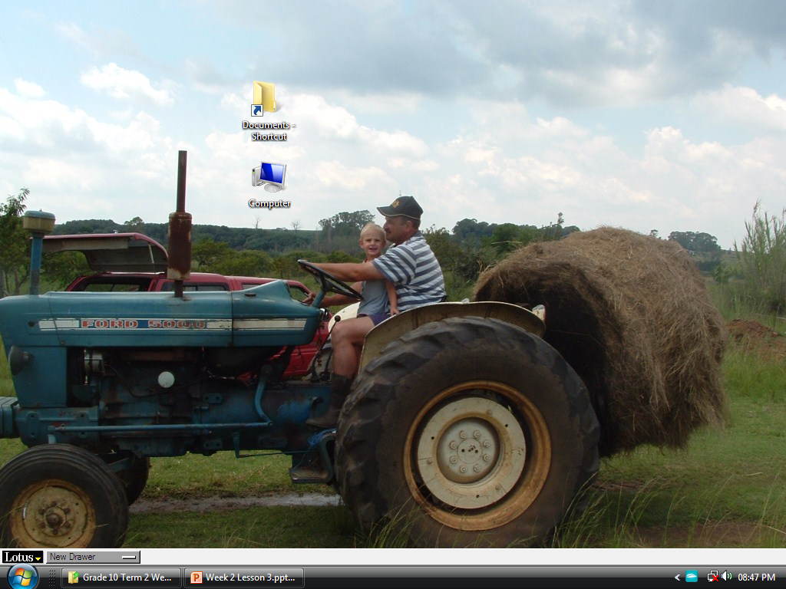  Compressing files  - Compres or Zip a folder to make it smaller maybe for sending with email.  - First find the file or folder that you want to compress, click right on the folder and choose send to and then compressed file.  Decompressing files  - Decompres or UnZip a folder to change it back to its original size or simply to open it so that you can acces the file again.  - First find the file or folder that you want to decompress, double click on it and it will open.  4. Conclusion  Learners will not grasp the concept only by looking at the PowerPoint Slides they will have to practice this on the computer, Open the activity and help them practise the Screenshot, Shortcut and Zip and Unzip functions |  |  |  |  |  |  |  |  | Practise folder with activity in die data folder available |  |  |  | 20 min explaining the four concepts  40 min practice these concepts on the computer | Microsoft PowerPoint, Projector,  Printer,  Computer  Textbooks:  Computers part of your life Grade 10  Learners book and teachers guide  Via Africa Learners book and Teacher guide.  Focus Computer Applications technology  PowerPoint  Week 2 Lesson 3.pptx

Name of Teacher: HOD:
Sign: Sign:
Date: Date:

